Steps for getting link for aculynk:

1. Open SQL Management service
2. Select New Query

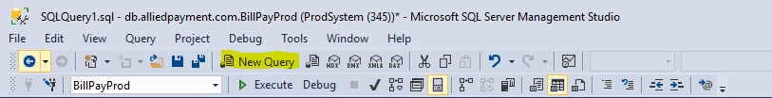

1. Type: *select LogoPictureId from FinancialInstitutions where domain = 'fishardkey'*
2. Copy results:



1. Replace LogoPictureId IN this url with the new LogoPictureId:

<https://api.alliedpayment.com/pictures/DFF5B703-27A8-4F6A-B9F2-2A1643C90F85/FILogo.jpg>

1. Paste url in comments of the ticket.